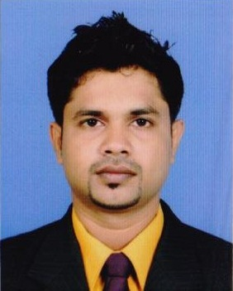**S. Ranila Supun Ekanayake**

**# 654/15,**

**Halgahadeniya,**

**Angoda.**

**Contact No - +94718554511**

**+94719977868**

**E-mail: *rsupun@sltnet.lk***

***darcknightrana@gmail.com***

Personal statement

To become a successful and ethical professional with excellent track records in the field of Refrigeration, Reefer container air conditioning and Air-conditioning in addition to the growth of the organization together with self-career development.

Employment History

**National Apprentice and Industrial Training Authority**

(Date of completion 28.02.2008)

I have two years work experience in Refrigeration and Air-conditioning.

**Marine Survey & Technology Services (pvt) Ltd**

(October 2008 –April 2011)

I have two and half years experience in PTI and repairing of Reefer container (Thomoking, Carrier, Daiking, Star cool).

**Marceng (pvt) Ltd.**

(May 2011 – up to date)

I have four years experience in PTI and repairing of Reefer container (Thomoking, Carrier, Daiking, Star cool).

**Education Qualification**

* Passed the G.C.E O/L Examination (December 2004) with 05 passes.

Personal Data

Name in full : Samarappulige Ranila Supun Ekanayake

Date of Birth : October 26, 1988

Civil Status : Single

Gender : Male

N.I.C. No : 883001737V

Other Qualification

* I have experience of working in JCT, SAGT, UCT, CICT terminals under Colombo port.
* I have driving License A1,A,B.

I do hereby declare that the above particulars furnished by me are true and accurate to the best of my knowledge

S.R.S. Ekanayake 20/02/2015

Signature Date