**RESUME**

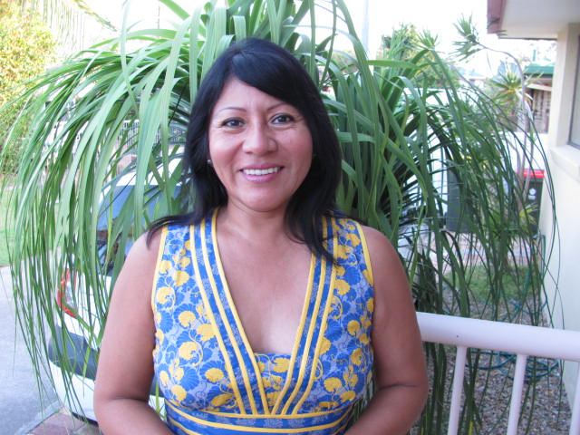

**Vilma Sarmiento Thompson**

**Mobile phone: 0401714254**

**119 Kirra Shores, 20 Binya Av**

**Email: vilmagthompson@yahoo.com.au**

**Personal Strengths:**

* **Reliable, responsible , friendly with a positive attitude**
* **Strong work ethic and uses of integrity**
* **Hard worker as a team member or as an individual with initiative**
* **Willing to learn more**

**Education:**

* **Certificate of Completion, Teaching Students with Autism: Strategies for success at ACE Community College online learning 2015**
* **Certificate of Completion, Teaching Students with Learning Disabilities at ACE Community College , online learning 2014**
* **Course Certificate Children Services at TAFE 2011**
* **English Course at King’s International College 2008**
* **Certificate of Completion: Comprehension-Oriented teaching I. Online course of Wide World Graduate School of Education 2008**

**ADDITIONAL SKILLS:**

* **Languages spoken: Spanish and English**
* **Police Certificate ( current)**
* **Blue Card (2012- 2014)**
* **Certificate First Aid (2011) - TAFE**
* **Skills of operating Microsoft Word, Excel, Power Point and Internet.:**

**WORK EXPERIENCE:**

* **I have experience in tutoring Spanish language to adult students from home in Queensland in 2014.**
* **Classroom Teacher in a primary school at Sophianun School Lima- Peru, from 2010 to 2011 Spanish.**
* **Classroom Teacher at general Prado School Lima – Peru, from 2000 to 2007. Duties : Planning and implementing classroom programs, regular reporting and extra-curricular activities .**
* **Volunteer work: I worked for the Foundation For Peruvian Children, where my role included developing academic reinforcement workshop and social skills activities trough games , playing , dance, song in Ayacucho- Peru, 2005. I enjoyed working on my own initiative and in a team .**

**REFERENCES:**

**Miranda Delaney. Adult Student of Spanish in Gold Coast. Phone: 0431256030**